Assignment Day 3

Q1 Length of string

using System;

using System.Collections.Generic;

using System.Linq;

using System.Text;

using System.Threading.Tasks;

namespace AssignmentDay3

{

class Program

{

static void Main(string[] args)

{

string ValString;

Console.Write("Enter Your String:");

ValString = Console.ReadLine();

int x = 0;

foreach (char c in ValString)

{

Console.Write(ValString[x]);

x++;

}

Console.WriteLine("\nLength Of String:{0}", (x));

Console.Read();

}

}

}

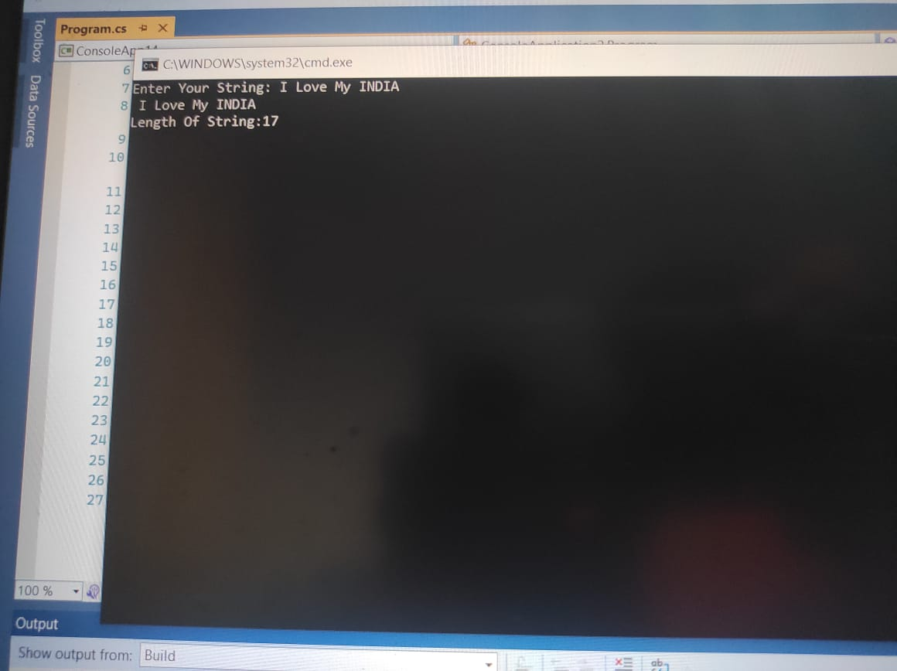

Q 2 reverse string

using System;

using System.Collections.Generic;

using System.Linq;

using System.Text;

using System.Threading.Tasks;

public class assignmentday3

{

public static void Main()

{

string str;

int l = 0;

Console.Write("Input the string : ");

str = Console.ReadLine();

l = str.Length - 1;

Console.Write("The characters of the string in reverse are : \n");

while (l >= 0)

{

Console.Write("{0} ", str[l]);

l--;

}

Console.Write("\n\n");

}

}

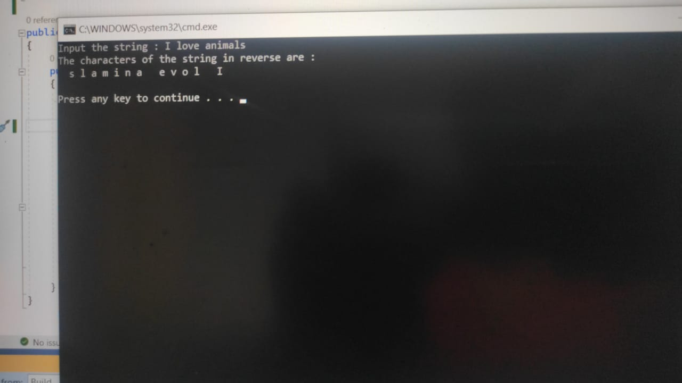

Q 3 odd even no.

using System;

using System.Collections.Generic;

using System.Linq;

using System.Text;

using System.Threading.Tasks;

public class Assignmentday3

{

public static void Main()

{

int[] arr1 = new int[10];

int[] arr2 = new int[10];

int[] arr3 = new int[10];

int i, j = 0, k = 0, n;

Console.Write("\n\n odd and even integers in separate arrays: \n");

Console.Write("------------------------------------------------------\n");

Console.Write(" Enter the number of elements to be stored in the array :");

n = Convert.ToInt32(Console.ReadLine());

Console.Write("Input {0} elements in the array :\n", n);

for (i = 0; i < n; i++)

{

Console.Write("element - {0} : ", i);

arr1[i] = Convert.ToInt32(Console.ReadLine());

}

for (i = 0; i < n; i++)

{

if (arr1[i] % 2 == 0)

{

arr2[j] = arr1[i];

j++;

}

else

{

arr3[k] = arr1[i];

k++;

}

}

Console.Write("\nThe Even elements are : \n");

for (i = 0; i < j; i++)

{

Console.Write("{0} ", arr2[i]);

}

Console.Write("\nThe Odd elements are :\n");

for (i = 0; i < k; i++)

{

Console.Write("{0} ", arr3[i]);

}

Console.Write("\n\n");

}

}

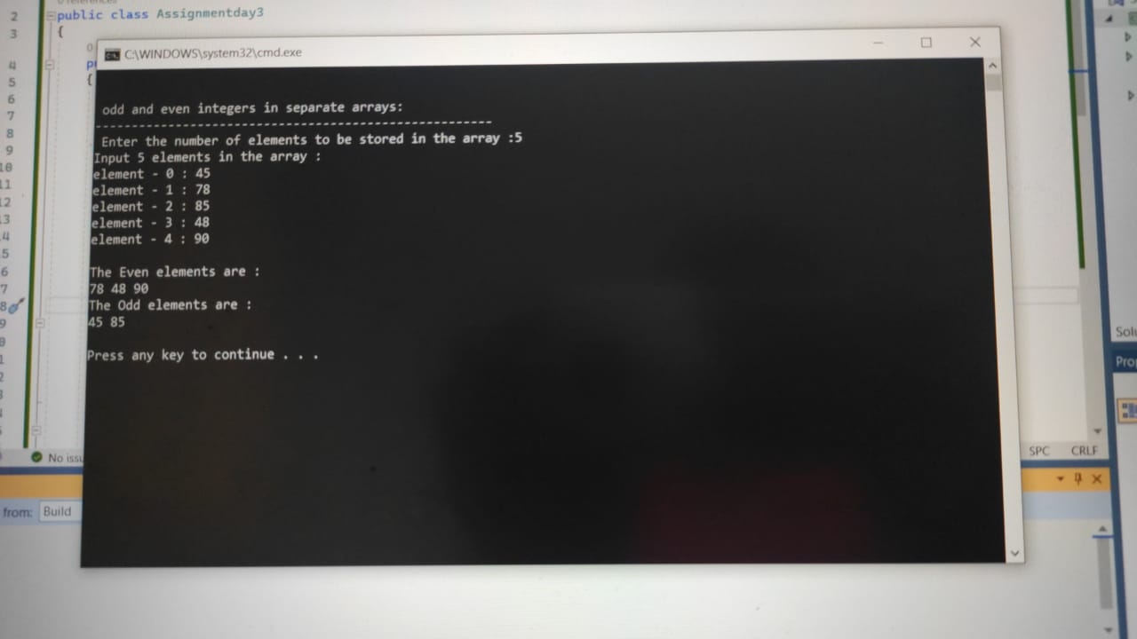

Q 4 greatest number smallest number

using System;

using System.Collections.Generic;

using System.Linq;

using System.Text;

using System.Threading.Tasks;

namespace assignmentday3

{

public class Demo

{

public static void Main()

{

int[] arr = new int[5] { 109, 45, 90, 75, 108 };

int i, greatest, smallest, n;

n = 5;

greatest = arr[0];

smallest = arr[0];

for (i = 1; i < n; i++)

{

if (arr[i] > greatest)

{

greatest = arr[i];

}

if (arr[i] < smallest)

{

smallest = arr[i];

}

}

Console.Write("greatest number = {0}\n", greatest);

Console.Write("smallest number = {0}\n\n", smallest);

}

}

}

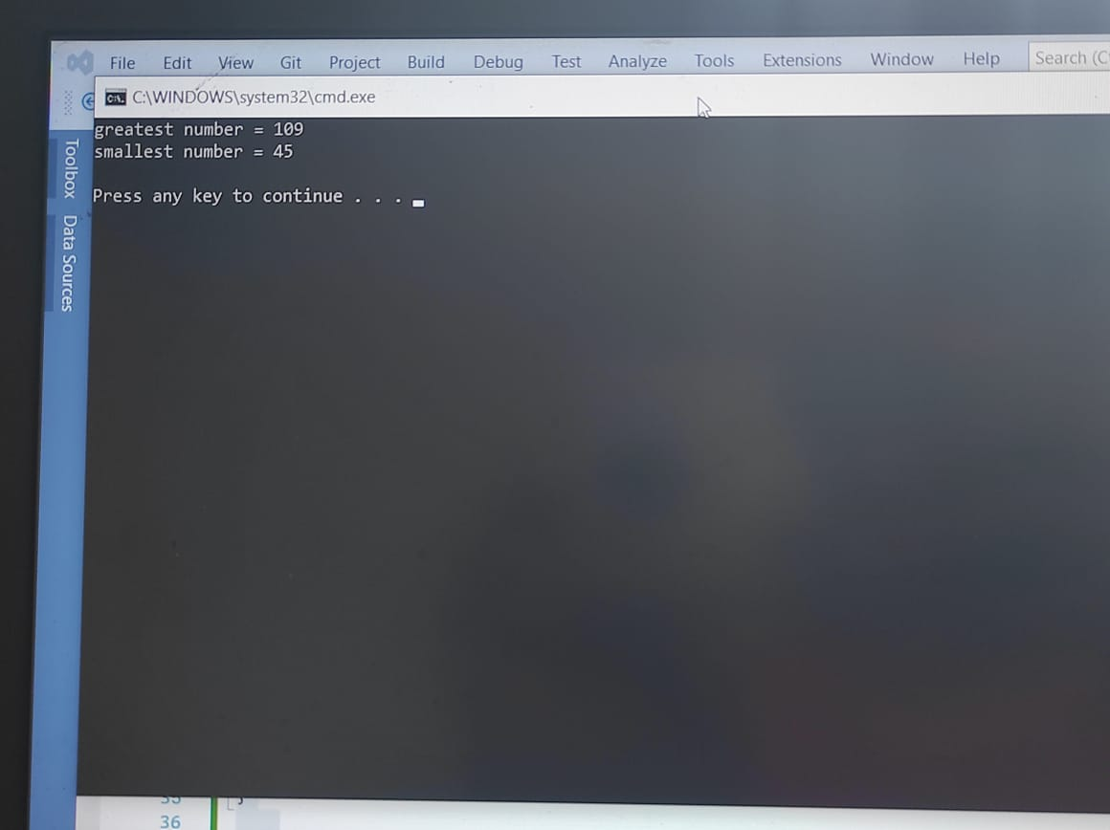

Q : 5 Ascending and Descending order

using System;

using System.Collections.Generic;

using System.Linq;

using System.Text;

using System.Threading.Tasks;

namespace AssignmentDay3

{

internal class Program

{

static void Main(string[] args)

{

int[] arr = new int[] { 11, 21, 28,98, 40, 5 };

Array.Sort(arr);

Console.WriteLine("Ascending Order :");

foreach(int value in arr)

{

Console.WriteLine(value + " ");

}

Array.Reverse(arr);

Console.WriteLine("\n\nDescending Order ");

foreach (int value in arr)

{

Console.WriteLine(value + " ");

}

}

}

}

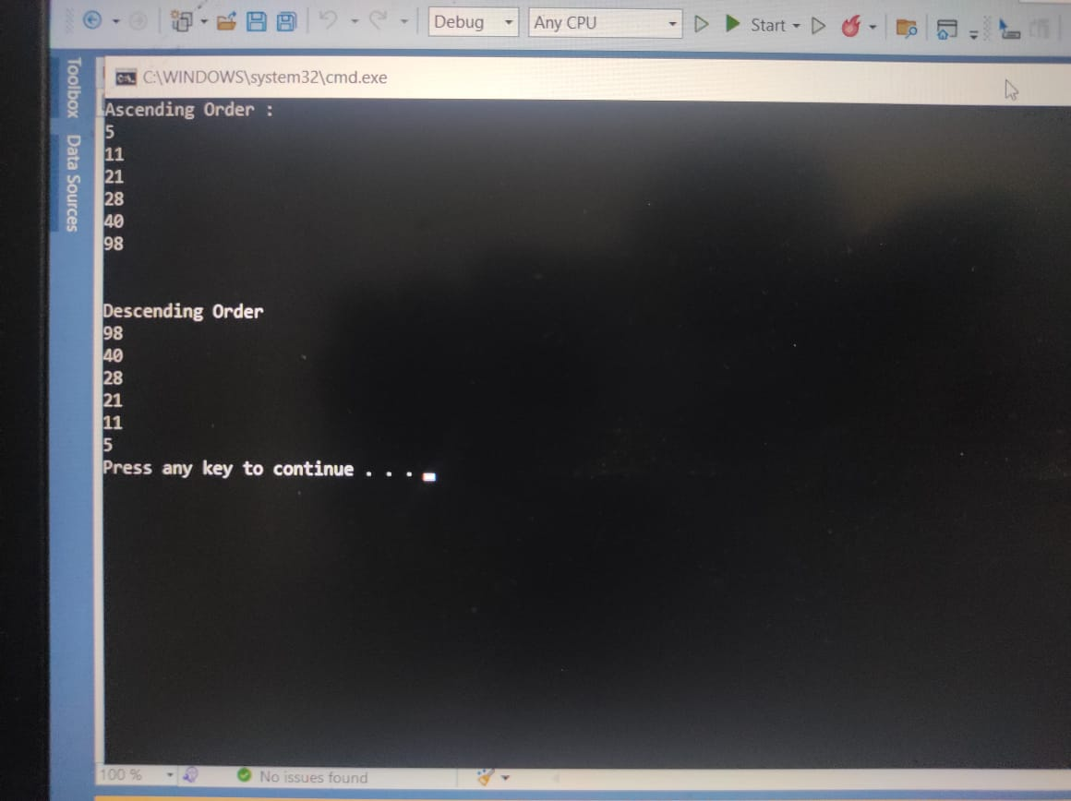

Q 5 Book id ,name, price , author ,

using System;

using System.Collections.Generic;

namespace AssignmentDay3

{

class Books

{

public int BookID { get; set; }

public string BookName { get; set; }

public string BookPrice { get; set; }

public string BookAuthor { get; set; }

}

class property

{

public static void Main(string[] args)

{

Books books = new Books();

books.BookID = 121;

books.BookName = "Rich Dad Poor Dad";

books.BookPrice = "190 Rs";

books.BookAuthor = "Robert T. Kiyosaki";

Console.WriteLine("BookID : {0} ", books.BookID);

Console.WriteLine("Name of the book : {0} ", books.BookName);

Console.WriteLine("Price of the book : {0}", books.BookPrice);

Console.WriteLine("The Author of the book: {0} ", books.BookAuthor);

}

}

}

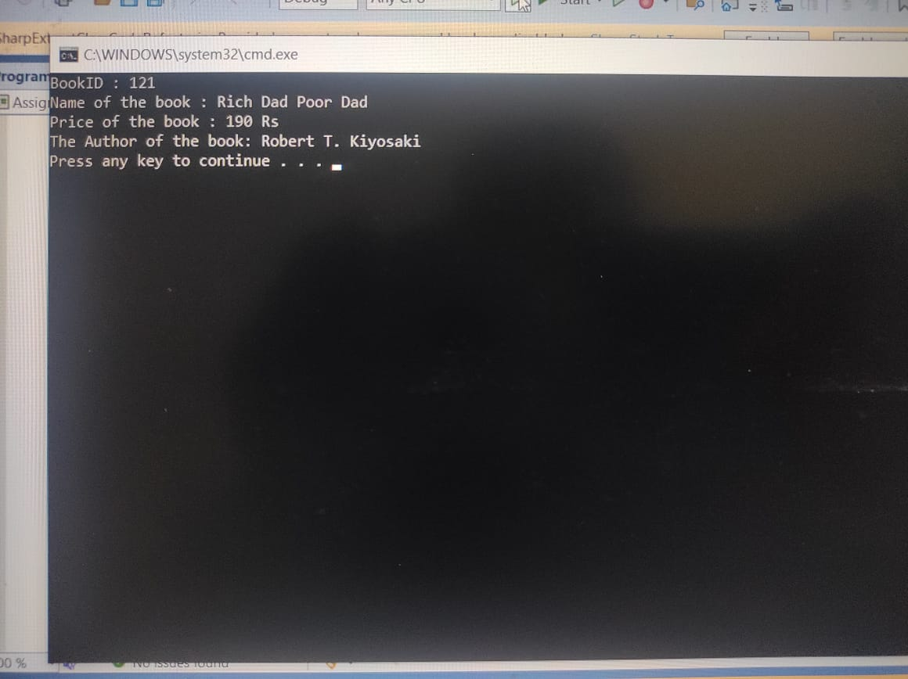

Q 6 swap

using System;

public class Exercise5

{

public static void Main(string[] args)

{

int number1, number2, temp;

Console.Write("\nInput the First Number : ");

number1 = int.Parse(Console.ReadLine());

Console.Write("\nInput the Second Number : ");

number2 = int.Parse(Console.ReadLine());

temp = number1;

number1 = number2;

number2 = temp;

Console.Write("\nAfter Swapping : ");

Console.Write("\nFirst Number : " + number1);

Console.Write("\nSecond Number : " + number2);

Console.Read();

String a , b, t;

a = Console.ReadLine();

Console.Write("\nInput the First String : ");

a = (Console.ReadLine());

Console.Write("\nInput the second String : ");

b = (Console.ReadLine());

t =a;

a = b;

b = t;

Console.Write("\nAfter Swapping : ");

Console.Write("\nFirst string : " + a );

Console.Write("\nSecond string : " + b );

Console.Read();

}

}

